844G Integrated ONT Provisioning - CALIX E7 (COR–TSC and QF Tech Assist)

1.0 Overview 3
2.0 Effective Date 3
3.0 Related Documents 3
4.0 844G ONT 3
5.0 Switching from GE to RG Programming 3
6.0 Switching from RG to GE Programming 6
7.0 Auto-Switch Overview 11
8.0 Changing ONT type from 844G to 803G or C5500XK 12
9.0 Document Management 19

Overview

Target Audience | Programming | Assignments
Impact/Benefit | The following Job Aid outlines the steps to change to or from 700 & 803 series ONT programming to 844G. These steps are required to get PING, when changing between ONT types.
Reason for Change | Added notes to not delete ONT ID when changing programming in Calix Management system (CMS).

Effective Date

Effective Date | Expiration Date
11/11/21 | Until Further Notice

Related Documents

Document Name
Visit the library to view all documents: https://centurylink.sharepoint.com/sites/NAOLibrary

844G ONT
844G is an integrated, all in one, ONT type that includes a built-in modem and ATA (analog telephone adapter). This ONT type uses the RG (residential gateway) port to program service, instead of the traditional GE port. When using the RG port, an ONT will incorporate all 4 GE ports, which means programming to the RG port will allow the technician to use ports 1, 2, 3 or 4 to get ping. If GE port 1 goes bad or does not ping, technicians can plug into port 2, 3 or 4 and attempt ping without re-programming service.

Special Notes on Programming:
- Steps need to be performed in the CMS.
- 844G ONTs use RG (residential gateway) ports to program service, not the traditional GE ports.
- An enhancement to CALIX allows Auto-Switch of the pre-provisioned GE services to 844G/RG services after RONTA is performed.
- If the ONT settings do not switch from GE to RG provisioning after RONTA of an 844G, the agent must manually change the settings or else the service will not PING.

Switching from GE to RG Programming
Important: to maintain database integrity, it is necessary to follow the steps below. Do not delete the ONT ID.

Overview of Steps:
- Remove GE Programming
- Change ONT Profile & Template to 844G.
- Re-program as RG Service (Residential Gateway port)

*See Switching from RG to GE Programming if agent is changing from 844G to another ONT type.

Step | Action
Remove GE programming. Under the GE port, change BW Profile to Remove Service and select Apply.
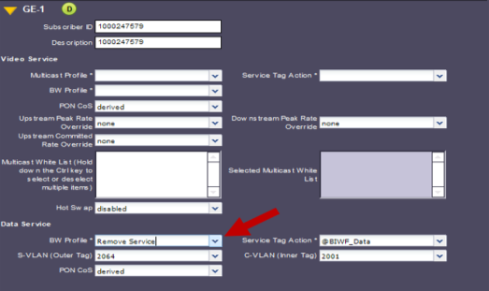
Select Provisioning (top menu).
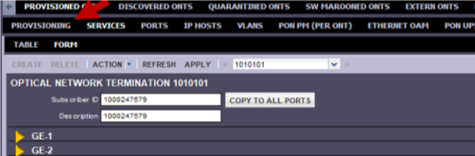
Change ONT settings to 844G. Change ONT Profile to 844G and select Apply.
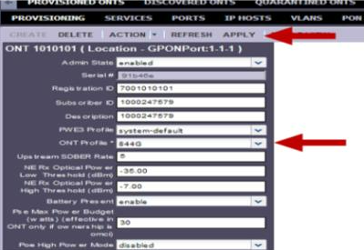
Select Action (top menu) and Apply Template to ONT.
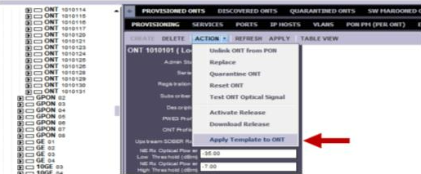
When the Apply Template box opens, select 844G and Apply Template.
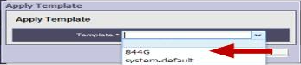
Reprogram as RG Service. Select Services (top menu).
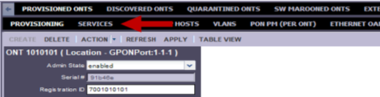
The agent will now see RG-1 instead of GE-1. Apply services as shown below:
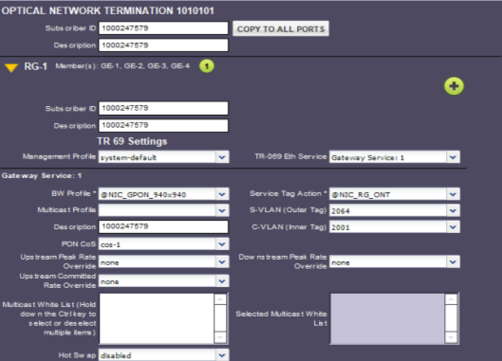
Subscriber ID & Description = Customer DTN
Management Profile = System-Default TR-069 Eth Service = Gateway Service: 1
BW Profile = @NIC_GPON_Speed S-VLAN = VPI
Description = Customer DTN C-VLAN = VCI
PON CoS = cos-1

Switching from RG to GE Programming
Important: to maintain database integrity, it is necessary to follow the steps below. Do not delete the ONT ID.

Overview of Steps:
- Remove RG-1 Programming
- Change ONT Profile & Template to 700 or 803
- Re-program as GE Service

*See Switching from GE to RG Programming if agent is changing from 700 or 803 series to 844G

Step | Action
Remove RG programming. Under the RG port, change BW Profile to Remove Service and select Apply.
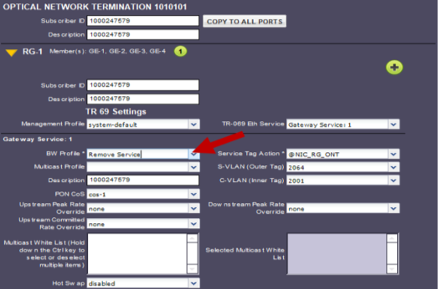
Select Provisioning (top menu).
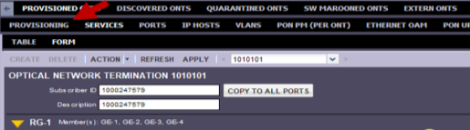
Change ONT settings to 700/803 series. Select Action (top menu) and Apply Template to ONT.
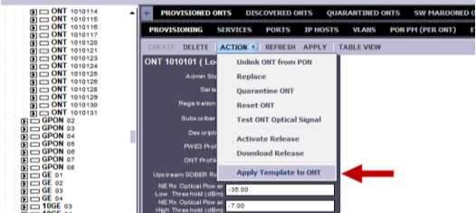
When the Apply Template box opens, select System-default and Apply Template.
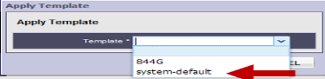
Note: We must take an extra step to clear RG from each GE port to completely remove the 844G/RG settings. Select Ports (top menu).
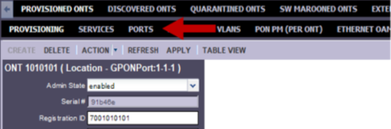
Select GE-1.
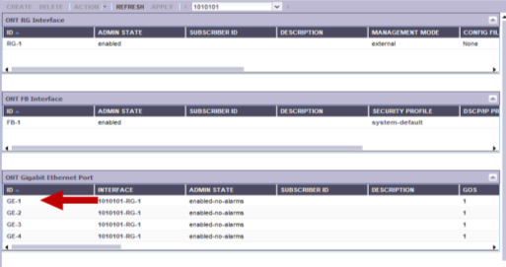
Change Interface from RG-1 to the blank option in the drop down and select Apply.
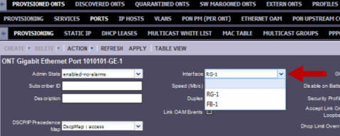
Important: must Repeat this step for each GE port on the ONT.
Tip: If the ONT is linked, the agent can highlight the GE ports under the ONT (left side) and select Provisioning (top menu) to adjust interface settings.
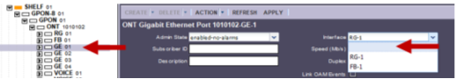
Select Provisioning (top menu).
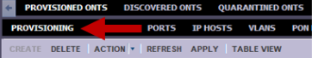
Change ONT Profile to match ONT model placed in field and then select Apply.
The example below is changing from 844G to 711GE.
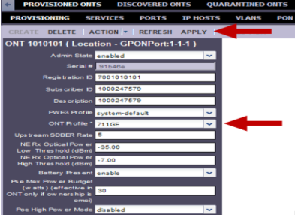
Reprogram as GE Service. Select Services (top menu).
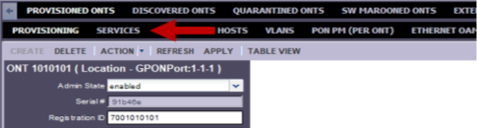
The agent will now see GE-1 instead of RG-1. Apply services as shown below.
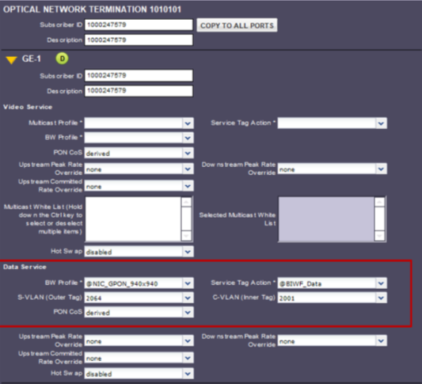
Data Service
Subscriber ID & Description = Customer DTN
BW Profile = @NIC_GPON_Speed Service Tag Action = @BIWF_Data
S-VLAN = Assigned VPI C-VLAN = Assigned VCI

Note: Ensure cross connects for 700/803 series ONTs under Data Service is being programmed.

*For Legacy Service: BW Profile should be @GPON Customer’s Speed and the Service Tag Action of @Enter S+C VLANS

Auto-Switch Overview
An upgrade to CMS allows auto-switch of settings after an ONT is RONTA’d.

Example: If an ONT is programmed as 700 series with GE services and an 844G ONT is connected,

CMS will automatically switch to 844G and move to RG-1 provisioning.

Special Notes on Auto-switch:

- CMS must be set up with specific service tags for Auto-Switch to work.
- When auto-switch has occurred, service tag action will show @auto-change-4099-and-add-4099.
- The auto-switch of settings will only occur once. If the technician uses an 844G & auto-switch changes to RG settings, the technician is encouraged to replace with a like ONT type when possible.
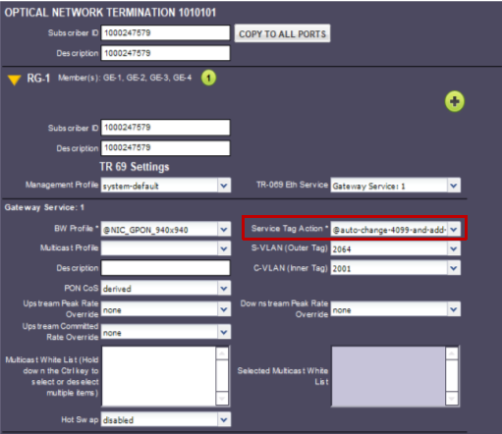

Changing ONT type from 844G to 803G or C5500XK
Previously 844G ONT’s were only used for CTL-ON and Instant Internet MDU Properties. If the technician needs to replace the 844G, whenever possible it should be replaced with a different 844G. If that is not possible, recommend that an 803G be used. A C5500KX maybe used if the technician does not have an 803G. Here are the steps to update the provisioning when changing from an 844G to an 803G or C5500XK.

Note: Do not delete the existing ONT.
Step | Action
Open the Calix
- Input the device CLLI followed by a colon (:) in the search box at the top and select Enter.
- Select the corresponding result in the ID column.

Note: the ONT ID (i.e., RONTA # without the first three digits) can be entered after the colon. Not inputting the ONT ID will result in a list to select a result from as shown below.
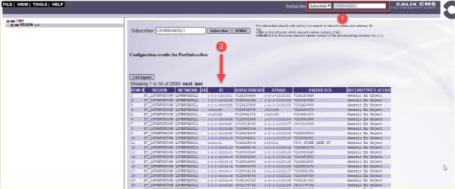
The screen should be updated to the PROVISIONED ONT tab (see #1), and the PROVISIONING tab (see #2) is displayed. Select the SERVICES tab (see #3).
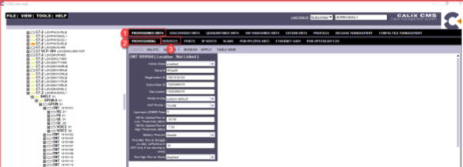
Select the FORM tab.
- Locate the GE port to be edited.
- Locate the Data Service BW Profile
- In the drop-down Select Remove Service
- Select Apply
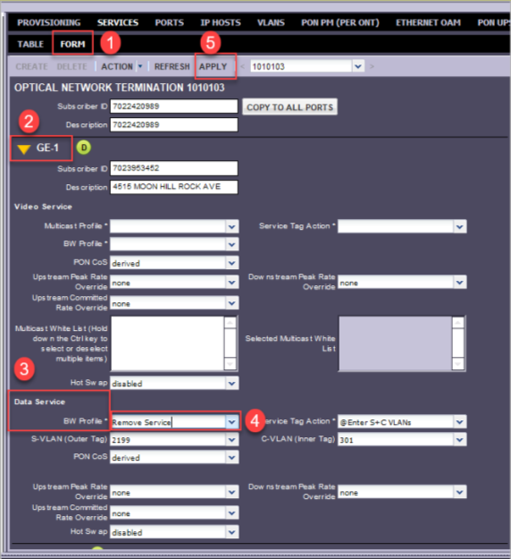
Select the PROVISIONING tab.
- Select ACTION drops down.
- Select Apply Template to ONT
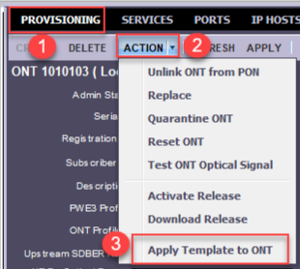
The Apply Template window will appear. In the Template drop down, select system-default. Select APPLY TEMPLATE
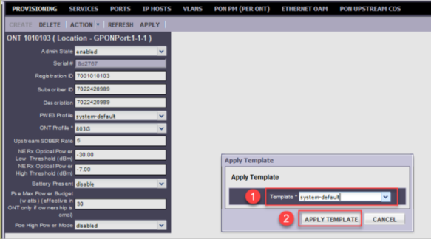
Select the PORTS tab. Locate the ONT Gigabit Ethernet Port section. Each GE port will be edited; these will need to be updated one at a time. Select the first GE port.
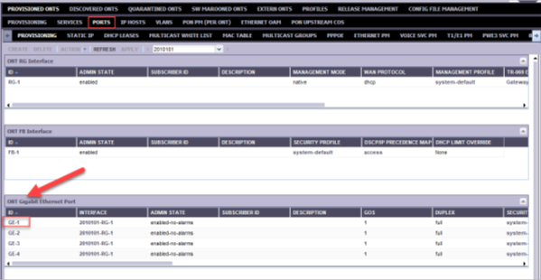
Locate the Interface field. In the drop down, select the blank option to remove existing entries. Select Apply (may take a few moments to update).
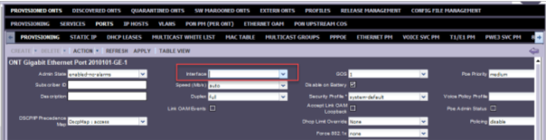
Select TABLE VIEW to go back to the prior screen. Repeat updating each GE port until all have been updated.
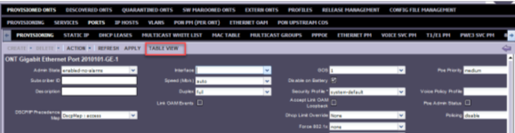
Select the PROVISIONING tab (on the second line).
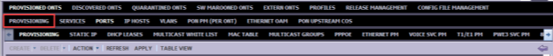
Enter the ONT ID in the ID search box. Select APPLY
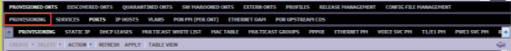
Select the ONT ID
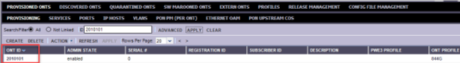
Locate the ONT Profile field and select the drop down. Locate the new ONT Profile (may need to scroll down) and select it. Select Apply
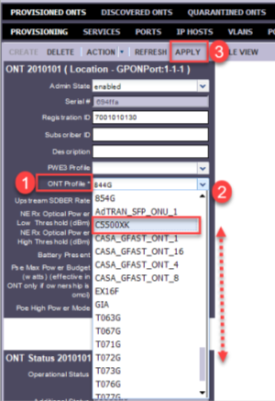
A pop-up confirmation window will appear asking to confirm that the change should be applied. Select YES.
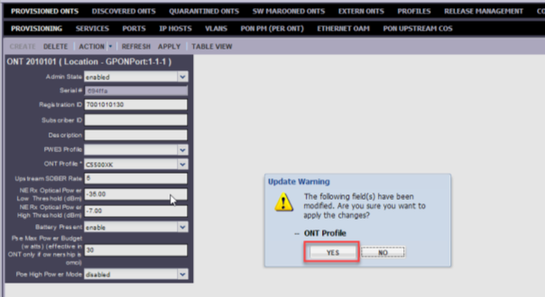
Select ACTION. In the drop down select Replace
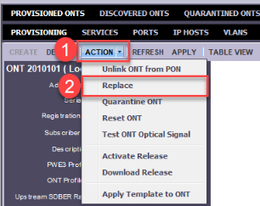
In the Replace window, replace the existing Serial # with the new Serial # Select a REPLACE.
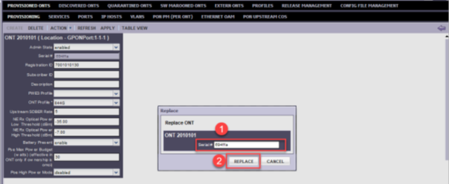
Select SERVICES tab.
- Locate the GE port to be edited.
- Input the DTN in both the Subscriber ID and Description fields.
- Locate the Data Service section and add provisioning including:
  - BW Profile: use the drop down to select the speed.
  - Service Tag Action: use the drop down to select @HSI_Data
  - S-VLAN (Outer Tag): input the SVLAN.
  - C-VLAN (Inner Tag): input the CVLAN 5)
- Select Apply
 | Verify in QRAD, Radius, or Poll DSLAM that an IP address is received.

Document Management

Document Management
AUTHORS
Author | SME |  | Name |  |  | Telephone Number | E-mail Address
X |  |  | Debra Rudrud |  |  | 608-615-4215 | debra.rudrud@lumen.com
REVISIONS
Date |  | Issue |  | Revised By | Comments
11/11/21 |  | 1 |  | Angela Cox | Initial Version
06/23/22 |  | 2 |  | Angela Cox | Updated for Recertification
01/09/24 |  | 3 |  | Debra Rudrud | Changed document author from Angela Cox to Debra Rudrud. Added Changing ONT type from 844G to 803G or C5500XK section.
06/04/24 |  | 4 |  | Joela Flaxa | Converting from JA template to MP template.
05/28/25 |  | 5 |  | Joela Flaxa | Added note to not delete ONT ID when changing programming in CMS.
06/03/25 |  | 5 |  | Hope Marks | Title Update
APPROVAL
Name |  |  |  | Title |  |  |  | Date Approved
Jackie Stecher |  |  |  | Manager – Mass Markets Ops Excellence |  |  |  | 06/04/024

